The Invest Coach, Inc. Rough Draft / Structure Pages
Below I’ve compiled each page to highlight what I’d like to have changed
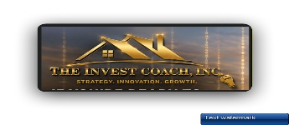
Remove old logo & replace it with this on the home pg, & all other pages, because it combines both the Logo & company name

Link the logo to the Mission & Our Story pages  And add the Mission & our Story tab  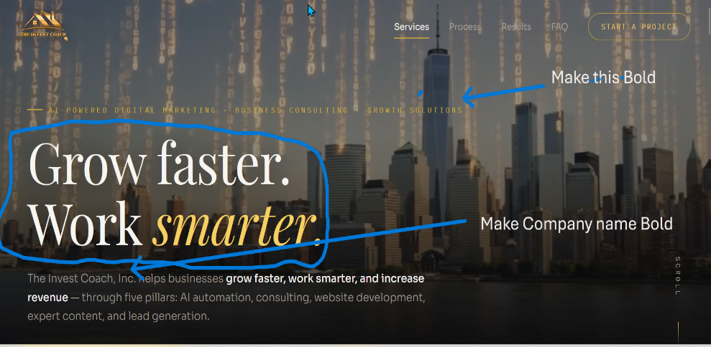 | → | Move the company name to the top left corner & place it after the logo, with the same color as the logo - The Invest Coach, Inc.  Make the featured items BOLD, make the small font size 1 step bigger & in bold. Also change the small font sizes to look the same on all other pages.  Replace the LARGE text with the phrase below “ helping Businesses Grow Faster, Work Smarter, and Increase Revenue “ leave the Sub-title: the same.

2nd pg the 5 Pillars
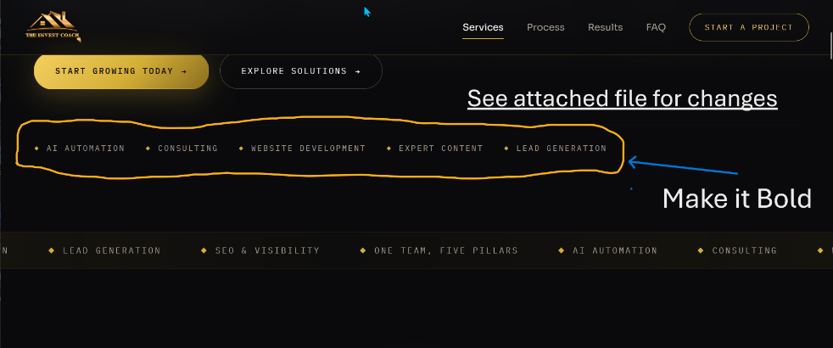 | → | Text Box 2: Feedback / Review  Make the featured items BOLD, make the font size 1 point bigger. Also change the font size to look the same on all other pages.
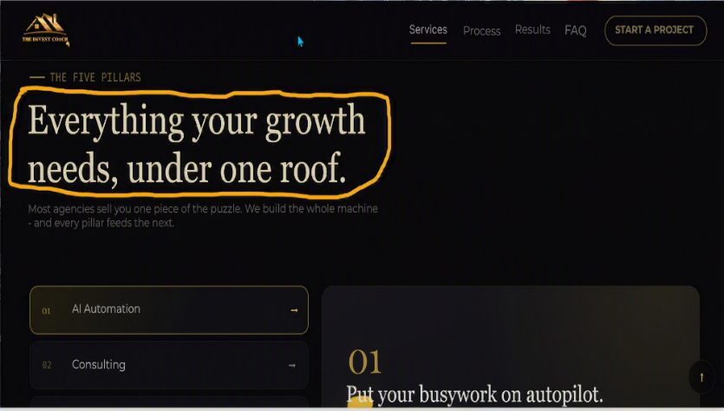 | → | change the font size to look the same on all other pages.  Replace this with: AI Has Changed Every Industry Worldwide  Sub-title:  Businesses that fails to adopt to Artificial Intelligence with Human ingenuity will soon lose their competitive edge.  s complete.
2nd Pg The 5 Pillar list

-------------------------------------------------------------------------------------------------------------

Pillar 1.

AI Automation

Smarter Systems That Save Time, Reduce Costs & Increase Productivity
Artificial Intelligence is transforming the way businesses operate. Our AI Automation solutions help companies eliminate repetitive tasks, streamline operations, improve customer experiences, and free teams to focus on higher-value work.
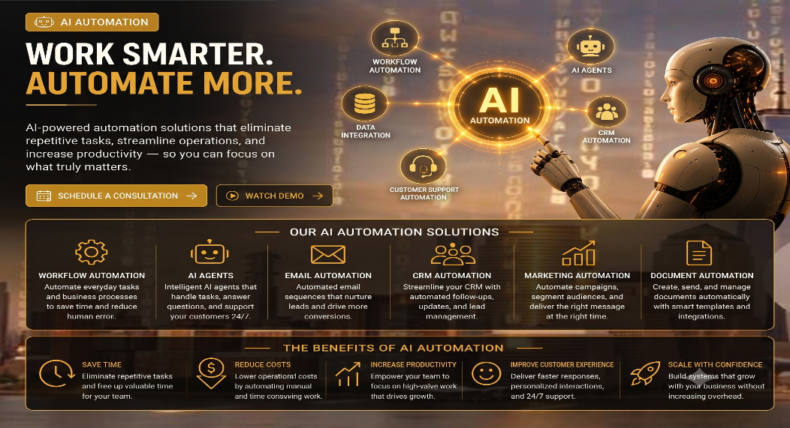
From intelligent workflows to AI-powered assistants, we help businesses integrate practical automations that delivers measurable results.
Services Include:
- AI Agents
- Workflow Automation
- CRM Automation
- Customer Support Automation
- Marketing Automation
- E-Mail Automation
Use background theme to cover the full page
Remove this section, because it’s already here

«

Pillar 2.

Business Consulting
Every successful business begins with a clear strategy, efficient operations, and informed decision-making. At The Invest Coach, we work alongside business owners to identify opportunities, eliminate inefficiencies, and build customized growth strategies designed to increase profitability, improve productivity, and create long-term sustainability.
Whether you’re launching a new business, expanding into new markets, or overcoming operational challenges, we provide practical guidance backed by decades of real-world business experience.
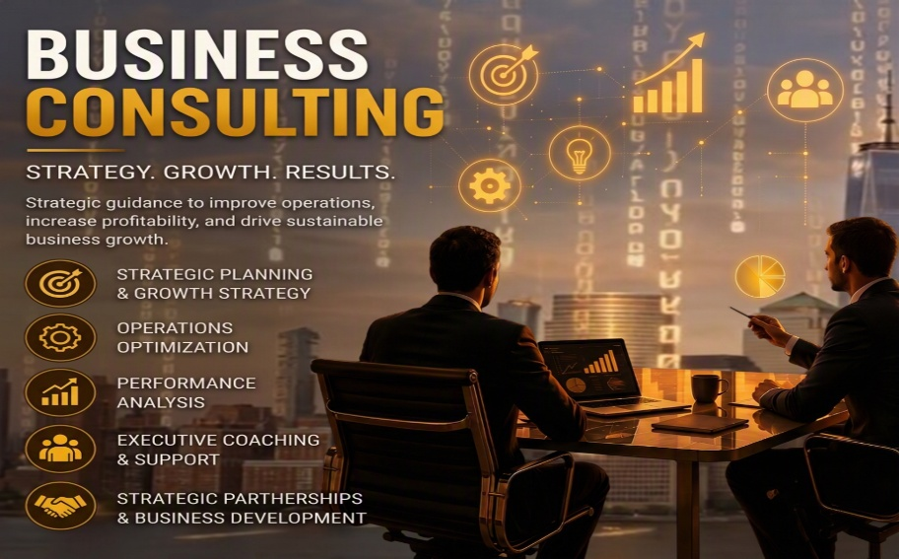
We specialize in uncovering overlooked opportunities to help you’re company identify hidden revenue.
Services Include:
- Business Strategy
- Growth Planning
- Operations Optimization
- Executive Coaching
- Process Improvement
- Performance Analysis

Use background theme to cover the full page

Pillar 3.

Modern Websites Designed to Convert Visitors Into Customers
Your website is often your first opportunity to make a lasting impression. We build professional, high-performing websites that not only look exceptional but are strategically designed to generate leads, build credibility, and support business growth. Every website is developed with speed, responsiveness, search engine optimization, user experience, and future scalability in mind. Whether you need a simple business website or a fully customized digital platform, we create websites that work as powerful marketing assets.

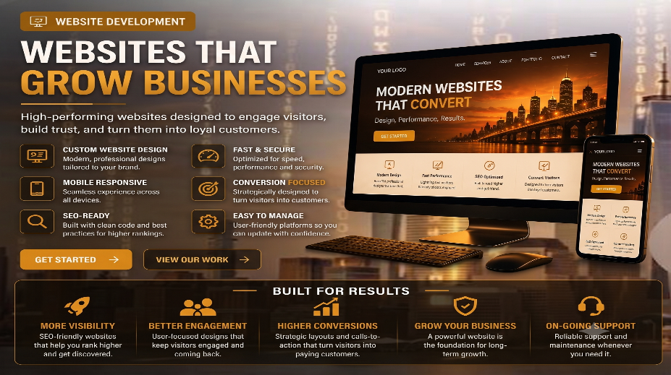
Services Include:
- Custom Website Design
- Landing Pages
- Website Redesign
- Mobile Optimization
- SEO-Friendly Development
- Website Maintenance

Use background theme to cover the full page
Remove this section, because it’s already here

Pillar 4.

Expert Content Creation

Is The Backbone of Every Successful Digital Marketing Strategy Every successful digital marketing strategy begins with exceptional content. From websites and blogs to videos, social media, email campaigns to news articles and AI-powered marketing assets, we create compelling content that builds trust, improves search visibility, strengthens your brand,

and turns prospects into loyal customers.
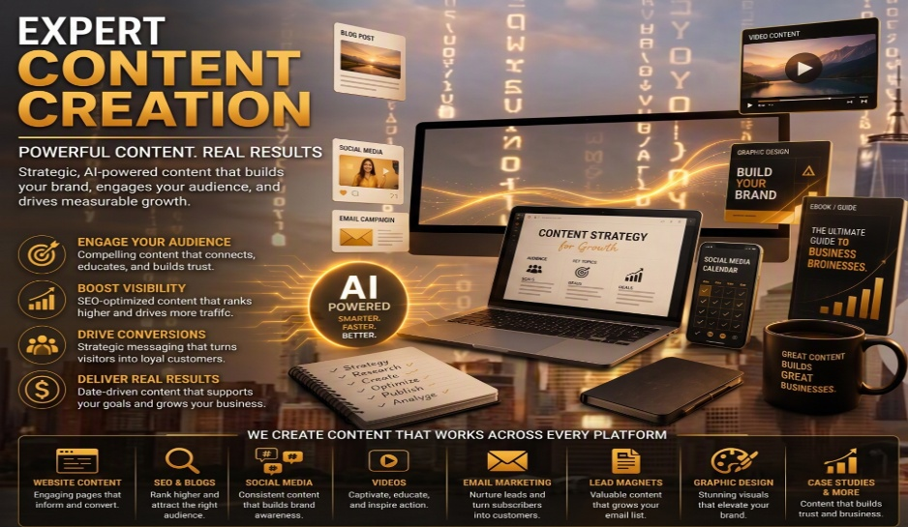
Services Include:
- Web Site Content
- SEO News Articles, Blog Posts & Pod-Cast
- Social Media Content
- Video Scripts & Production
- Email Marketing

It’s The Key to Converting Visitors Into Customers

Use background theme to cover the full page
Remove this section, because it’s already here

Pillar 5

Consistent Lead Generation That Fuels Sustainable Business Growth
Every growing business depends on a predictable flow of qualified leads. We build comprehensive lead generation systems that consistently attract potential customers, nurture relationships, and convert prospects into paying clients.
Instead of relying on one marketing tactic, we create multi-channel lead generation strategies that combine digital marketing, automation, optimized websites, content, and analytics to deliver measurable results.
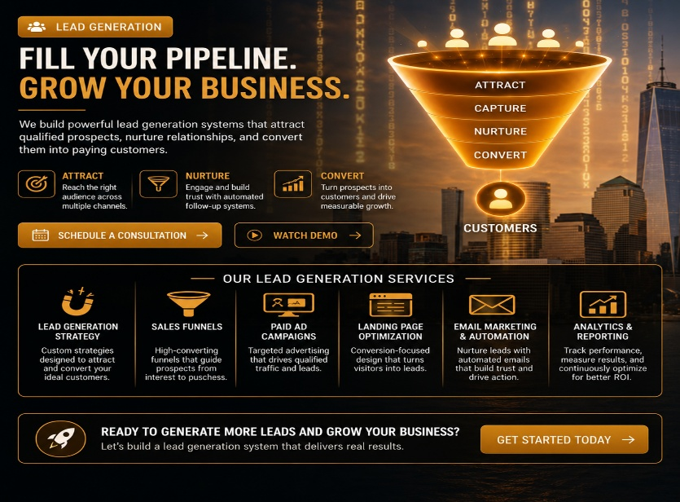
Our goal is simple: help you build a reliable sales pipeline that supports long-term growth.
Services Include:
- Lead Generation Campaigns
- Sales Funnels
- Landing Page Optimization
- Email Marketing
- Marketing Automation
- Conversion Optimization

Use background theme to cover the full page
Remove this section, because it’s already here

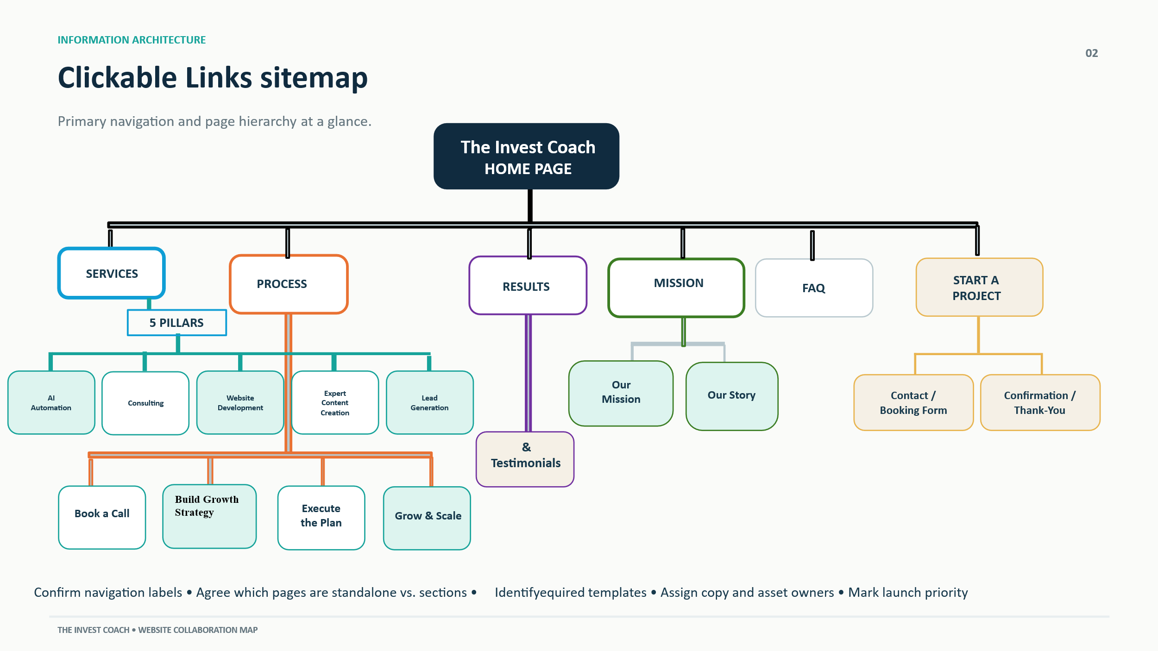
Link Logo to

Our Process

A Proven Framework for Building Smarter, Stronger & More Profitable Businesses
Every successful project begins with understanding your business, your goals, and your vision. That's why we don't believe in one-size-fits-all solutions.
Our process is designed to uncover opportunities, identify challenges, and build a customized strategy that aligns with your business objectives.
Whether you're looking for Business Consulting, Website Development, AI Automation, Expert Content Creation, or Lead Generation, our step-by-step approach ensures every recommendation is built around your success.

Step 1 — Book a Call & Let's Talk
Schedule a complimentary discovery consultation so we can learn about your business, your goals, and the challenges you're looking to solve.
✔ Understand Your Business
✔ Identify Your Goals
✔ Discover Growth Opportunities

Step 2 — Build Your Growth Strategy
After learning about your business, we'll recommend a customized strategy based on your objectives—not a one-size-fits-all solution.
Choose one service or combine multiple solutions:
- Business Consulting
- Website Development
- AI Automation
- Expert Content Creation
- Lead Generation

Step 3 — Execute the Plan
Once you're ready, we'll begin implementing your customized growth strategy while keeping you informed every step of the way.
✔ Clear Communication
✔ Professional Execution
✔ Measurable Progress

Step 4 — Grow & Scale - Follow-Up
Our partnership doesn't end at launch. We continuously refine, optimize, and improve your strategy to help your business stay ahead of the competition.
✔ Better Performance
✔ Smarter Decisions
✔ Sustainable Growth

Ready to Outperform Your Competition?
Every successful business starts with a conversation.
Let's discover what's possible for your business and build a strategy designed for long-term success.
Schedule Your Free Complimentary Strategy Session Today →

“ message to Gary “ an idea for less clutter to help make this page even more engaging
Instead of showing all four steps in a long vertical layout, present them as four horizontal cards connected by a gold line with arrows:
① Discover → ② Strategize → ③ Implement →
Each card would have:
- A premium gold icon
- A 1–2 sentence description
- A subtle hover animation
- A "Learn More" option (if needed)
At the bottom, place a large gold call-to-action banner:
"In just 30 minutes, we'll help identify opportunities to grow your business, improve your online presence, and develop a strategy tailored to your goals."
[ Schedule Your Free Strategy Session ]
==================================================================================

Our Mission

Empowering Businesses Through Innovation, Strategy & Technology
Our mission is to help businesses unlock their full potential by providing strategic consulting, innovative technology, AI-powered solutions, and results-driven digital marketing that fuel sustainable growth.
We are committed to helping entrepreneurs and business owners make smarter decisions, improve operational efficiency, attract more customers, and build organizations that are prepared for the future.
Through education, collaboration, and innovation, we strive to become a trusted partner in every stage of our clients' growth journey.

Our Story

Built on Years of Experience. Driven by Purpose.
Every successful business has a story—and so do we.
The Invest Coach, Inc. wasn't created overnight. It was built from decades of real-world entrepreneurial experience, learning, adapting, overcoming challenges, and discovering what truly drives long-term business success.
For more than 35 years, we've worked across multiple industries, building businesses, developing strategic partnerships, leading teams, solving complex business challenges, and helping companies identify new opportunities for growth. Along the way, we've experienced both successes and setbacks—giving us firsthand insight into the realities that business owners face every day.
Like many entrepreneurs, we've learned that success isn't determined by working harder alone. It comes from having the right strategy, the right systems, the right technology, and the ability to adapt as markets evolve.
That realization became the foundation of The Invest Coach, Inc.
Today, businesses face more competition than ever before. Artificial Intelligence, automation, digital marketing, search engines, and changing consumer expectations are transforming nearly every industry. While these changes create incredible opportunities, they can also feel overwhelming for business owners trying to keep up.
That's where we come in.
The Invest Coach was created to simplify that journey.
We help entrepreneurs and growing businesses navigate today's digital landscape by combining strategic business consulting with modern marketing, website development, AI-powered automation, expert content creation, and lead generation—all working together as one integrated growth system.
Our philosophy is very simple:
Technology should empower people—not replace them.
Marketing should generate measurable business results—not just clicks and impressions.
Every investment should contribute to long-term growth, stronger customer relationships, and sustainable success.
We don't believe in one-size-fits-all solutions. Every business has its own vision, challenges, strengths, and opportunities. That's why we take the time to understand your goals before recommending strategies designed specifically for your business.
Our success is measured by one thing:
Helping your business become stronger, more profitable, and better positioned for the future.
As technology continues to evolve, our commitment remains the same—to provide honest guidance, innovative solutions, and practical strategies that help businesses grow smarter, faster, and with greater confidence.
Whether you're launching your first business, expanding into new markets, modernizing your operations, or preparing for the next stage of growth, we're here to help you build something that lasts.

Your success is our mission. / Your growth is our purpose.

And your future starts today.
I’m not 100% clear how the remaining pages will be structured or linked to opt-in forms?
I need more details regarding the “3 Growth Audit & would like to reword the intro in Start a Project“

Contact Info:

The Invest Coach, Inc.

Office Location:

12550 Biscayne Blvd

N. Miami, Fla. 33181

